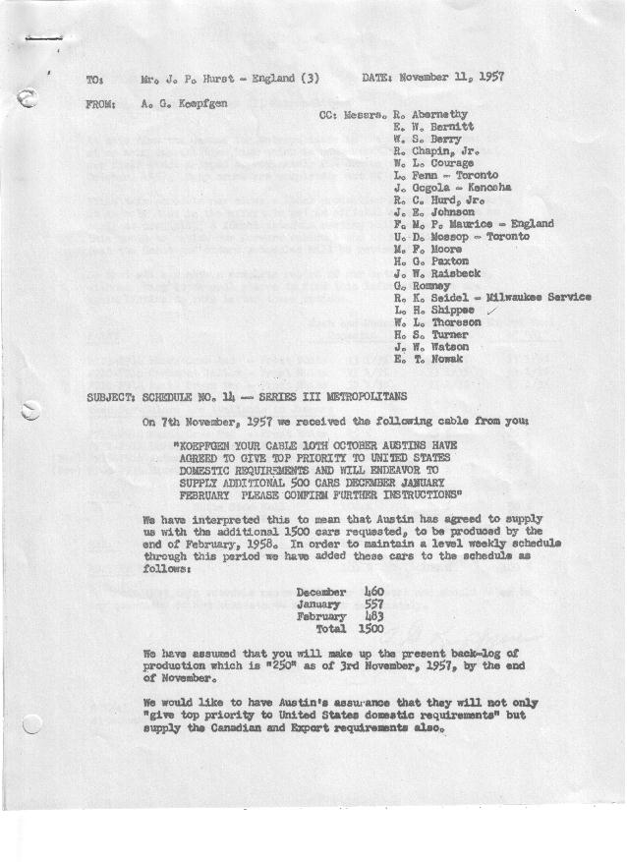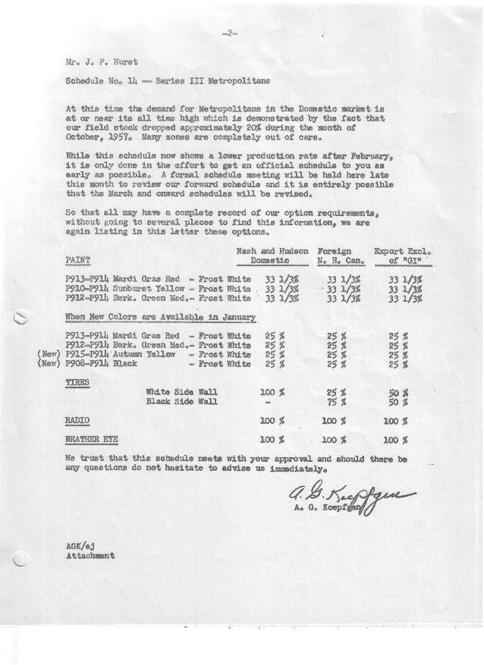

FORM PLAN 68 REV. 2-55-A.M.P APPROVED R. Abernethy (signed) DATE 11/11/57

SCHEDULE NO. ______14 ___ DATE 11-11-57 MONTHLY BUILDING SCHEDULE APPROVED E.W.Bernitt (signed) ___ _ DATE_ 11/11/57 _
REVISION NO. _______ ______ DATE PRODUCT APPROVED DATE _ ____
SERIES III 1500 c.c. ENGINE
METROPOLITAN SERIES CARS – AUSTIN MOTORS CO., LTD, ENGLAND
DESCRIPTION | BUILT  ◻ACTEST  THRU  10-31-57 | FIRM BUILDING SCHEDULE  (FABRICATED MATERIAL RELEASE) |  |  |  |  |  |  |  |  |  |  |  |  |  |  | TENTATIVE SCHEDULE  (RAW MATERIAL RELEASED) |  |  | GRAND  TOTAL
DESCRIPTION | BUILT  ◻ACTEST  THRU  10-31-57 | MONTH November  DAYS 21 |  |  | MONTH December  DAYS 19 |  |  | MONTH January “58”  DAYS 23 |  |  | MONTH February  DAYS 20 |  |  | MONTH March  DAYS 21 |  |  | MONTH April  DAYS 16.5 |  |  | GRAND  TOTAL
DESCRIPTION | BUILT  ◻ACTEST  THRU  10-31-57 | DAILY | MONTH | CUM’L  TOTAL | DAILY | MONTH | CUM’L  TOTAL | DAILY | MONTH | CUM’L  TOTAL | DAILY | MONTH | CUM’L  TOTAL | DAILY | MONTH | CUM’L  TOTAL | DAILY | MONTH | CUM’L TOTAL | GRAND  TOTAL
DOMESTIC LHD:
Hard-Top | 16567 |  | 1080 | 17647 |  | 1086 | 18733 |  | 1159 | 19892 |  | 1030 | 20922 |  | 659 | 21581 |  | 488 | 22069
Soft-Top | 2648 |  | 55 | 2703 |  | 130 | 2833 |  | 157 | 2990 |  | 113 | 3103 |  | 157 | 3260 |  | 155 | 3415
Total U.S. | 19215 | 54.0 | 1135 | 20350 | 64.0 | 1216 | 21566 | 57.2 | 1316 | 22822 | 57.2 | 1143 | 24025 | 38.8 | 816 | 24841 | 39.0 | 643 | 25484
Over/(Under) Schedule 13 | (85) |  | 85 | -0- |  | 460 | 460 |  | 557 | 1017 |  | 483 | 1500 |  | -0- | 1500 |  | (135) | 1365
FOREIGN:
EXPORT LHD Hard-Top | 605 |  | 65 | 670 |  | 20 | 690 |  | 40 | 730 |  | 30 | 760 |  | 30 | 790 |  | 25 | 815
Soft-Top | 294 |  | 27 | 321 |  | 8 | 329 |  | 12 | 341 |  | 9 | 350 |  | 10 | 360 |  | 8 | 368
Total Export LHD | 899 |  | 92 | 991 |  | 28 | 1019 |  | 52 | 1071 |  | 39 | 1110 |  | 40 | 1150 |  | 33 | 1183
RHD Hard Top | 166 |  | 112 | 278 |  | 14 | 292 |  | 60 | 352 |  | 30 | 382 |  | 30 | 412 |  | 23 | 435
Soft Top | 24 |  | 32 | 56 |  | 6 | 62 |  | 6 | 68 |  | 4 | 72 |  | 10 | 82 |  | 6 | 88
Total Export RHD | 190 |  | 144 | 334 |  | 20 | 354 |  | 66 | 420 |  | 34 | 454 |  | 40 | 494 |  | 29 | 523
Total Export LHD & RHD | 1089 | 11.2 | 236 | 1325 | 2.5 | 48 | 1373 | 5.2 | 118 | 1491 | 3.6(3.7) | 73 | 1564 | 3.8 | 80 | 1644 | 3.8(3.7) | 62 | 1706
Over/(Under) Schedule 13 | (156) |  | 156 | -0- |  | -0- | -0- |  | -0- | -0- |  | -0- | -0- |  | -0- | -0- |  | (13) | (13)
CANADA Hard-Top | 1919 |  | 39 | 1958 |  | 10 | 1968 |  | 110 | 2078 |  | 100 | 2178 |  | 200 | 2378 |  | 165 | 2543
Soft-Top | 148 |  | 0 | 148 |  | 5 | 153 |  | 5 | 158 |  | 30 | 188 |  | 50 | 238 |  | 29 | 267
Total Canada | 2067 | 1.9 | 39 | 2106 | .8 | 15 | 2121 | 5.0 | 115 | 2236 | 6.5 | 130 | 2366 | 11.9(12) | 250 | 2616 | 11.8 | 194 | 2810
Over/(Under) Schedule 13 | (9) |  | 9 | -0- |  | -0- | -0- |  | -0- | -0- |  | -0- | -0- |  | -0- | -0- |  | (41) | (41)
Total Foreign | 3156 | 13.1 | 275 | 3431 | 3.3 | 63 | 3494 | 10.2 | 233 | 3727 | 10.2 | 203 | 3930 | 15.8 | 330 | 4260 | 15.5 | 256 | 4516
Over/(Under) Schedule 13 | (165) |  | 165 | -0- |  | -0- | -0- |  | -0- | -0- |  | -0- | -0- |  | -0- | -0- |  | (54) | (54)
GRAND TOTALS
Hard-Top | 19257 | 61.7 | 1296 | 20553 | 59.5 | 1130 | 21683 | 59.5 | 1369 | 23052 | 59.5 | 1190 | 24242 | 43.8 | 919 | 25161 | 42.5 | 701 | 25862
Soft-Top | 3114 | 5.4 | 114 | 3228 | 7.8 | 149 | 3377 | 7.8 | 180 | 3557 | 7.8 | 156 | 3713 | 10.8 | 227 | 3940 | 12 | 198 | 4138
Total | 22371 | 67.1 | 1410 | 23781 | 67.3 | 1279 | 25060 | 67.3 | 1549 | 26609 | 67.3 | 1346 | 27955 | 54.6 | 1146 | 29101 | 54.5 | 899 | 30000
Over/(Under) Schedule 13 | (250) |  | 250 | -0- |  | 460 | 460 |  | 557 | 1017 |  | 483 | 1500 |  | -0- | 1500 |  | (189) | 1311

